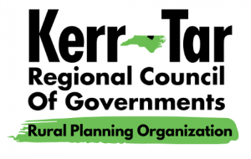

Kerr-Tar RPO TCC and TAC Meeting
Thursday, February 19th, 2026
3:00PM – 4:00PM

This will be an in-person meeting.. Members of the public may attend in-person.

- Roll Call to Establish Quorum
Establish quorum for Transportation Advisory Committee (TAC) Ty Cheek
Establish quorum for Technical Coordinating Committee (TCC) Ty Cheek

- Call to Order
TCC call to order Chairman Baker
TAC call to order Chairman Lane

- Ethics Awareness and Conflict of Interest Reminder
Pursuant to NCGS §138A-15 (e): Does any member have any known conflict of interest with respect to any matters coming before the board today? If so, please identify the conflict and refrain from any participation in the particular matter involved.

- Public Comments
This is the time set aside by the TAC Board to allow individuals to address the Board on issues concerning the RPO. The time limit for each speaker shall be five minutes with a total time limit set aside for informal public comments totaling 30 minutes. Vulgarity and abusive comments will not be tolerated.

- Item for Presentation –
Draft of Potential P8 Methodology Ty Cheek, Senior Planner

Draft PWP Ty Cheek, Senior Planner

- Items for TAC/TCC Approval
Draft of Potential P8 Methodology
Draft PWP
Minutes from October Meeting
7. NCDOT Division 5 Updates and Maintenance Reports
8. Informational Items – Kerr-Tar RPO Staff

Open Discussion

8. Member Updates from Around the Region/Open Discussion
9. Adjournment
Motion to Adjourn by TCC and TAC

Next Regular Meeting – March 19th, 2026

